
Module 16: Group Facilitation – Participant Handbook

Module 16 Resources: 2
Information from Module 16 Slides: 3
Homework Activity: 4

Module 16 Resources:

Centre for Innovation in Peer Support “Toolkit for Implementing Virtual Services”
https://www.peerworks.ca/de/cache/modules_listing/288/rs_Centre%20for%20Innovation%20in%20Peert%20Support_%20Our%20Virtual%20World%20-%20A%20Toolkit%20for%20Implementing%20Virtual%20Group%20Services%20v..._.pdf

Information from Module 16 Slides:

Things You Can Provide as a Group Facilitator:
- Acknowledge what the person has shared!
- Respond with affirmations that encourage them.
- Summarize or clarify what someone has said.
- Eye contact and body language that reflects non-judgemental active listening.
- Positive facial expressions, including nodding and smiling.

Conflict Resolution
- Focus on what the purpose of the group is and use affirmative language “Please focus discussion on the topic at hand” vs. “We don’t talk about those topics here.”
- Refer back to the collaboratively created guidelines.
- Use “I” sentences and encourage other group members to do the same: “I feel frustrated and not valued when my share is interrupted” vs “You interrupted my share and made me feel bad.”
- Try to engage all group members and suggest multiple options to move forward. During a conflict resolution you can even ask “Does everyone feel as though their voice has been heard?”
- If a resolution can’t be quickly reached, feel free take a break and give people time away to process.
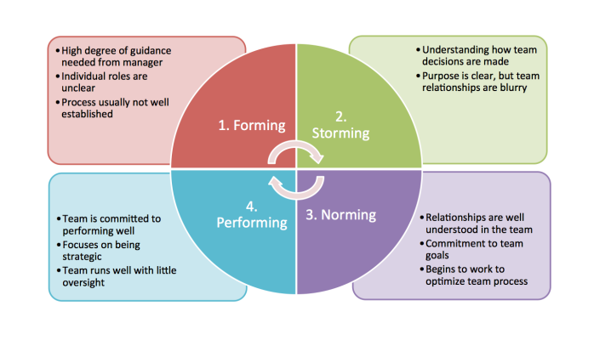

Homework Activity:

Bring any questions you have for the final module or send them to [Training Coordinator] at [email@peerworks.ca] in advance.

